Header;

Seminar Pembelajaran Sepanjang Hayat Peringkat Kebangsaan(SPSH 2025)  
Arial,8,Italic

Arial,14, Bold

**Title of Manuscript**

**Mohd Hashim Ahmad1,*, Nurfatin Azman2**

Arial, 12, Bold

(No bin/binti)

*1Institution Name [Arial,10, centered]*

*2Institution Name [Arial,10, centered]*

\**Corresponding author’s email: contoh@example.com*

Arial, 12, Bold

**Abstract**

The abstract must include the objectives, methodology, research findings, and conclusion, and must be written in a single paragraph. It must be concise yet comprehensive, enabling readers to quickly understand the content of the article. The abstract should be between 150 and 250 words and must not exceed 300 words, using Arial font, size 11, with single spacing. Articles may be submitted in either Malay or English, and must use only one non-justified paragraph. The abstract should cover, among other important points, the main research questions, primary objectives, the significance of the study, and the research methods employed. A brief explanation of the main research findings must be provided, and the study should conclude with several recommendations for further application. All these points must be presented in very concise language. The abstract must not contain symbols, special characters, footnotes, or mathematical equations in the title or the abstract.

Arial, 10, Justified

***Keywords*:** Minimum of 3 and maximum of 5 words only.

Arial, 12, Bold

1. **Introduction**

Manuscript must be written in **English**. The manuscript should be prepared using Microsoft® Word. It must be between 10 to 12 pages only, including tables, figures and a list of references. The text should be typed within a print area with margins like this template.

All text must be in [Arial, 12-point font, justified alignment, and single spacing]. Page margins must be 2.5 cm at the top, bottom, left, and right. The second and subsequent paragraphs must have 1-line spacing.

### **1.1 Sections in the Article**

### All text must consistently follow this format: Arial, 12-point font, single spacing, justified alignment.

### **1.2 Title and Subtitle**

### All titles must use Arial, 12-point font, in uppercase letters, and bold. Indentation is not required for each paragraph. There should be one line of spacing between the title and the following paragraph. Each new paragraph must begin one line below the last sentence of the previous paragraph.

Subtitle: All subtitles must use Arial, 12-point font, bold, with only the first letter of each word capitalized, except for common words. No spacing is required between the subtitle and the following paragraph.

The format and numbering style for titles and subtitles must follow the example provided.

Arial, 12, Bold

**2.0 Methodology / Materials and Metods**

All text must be in [Arial, 12-point font, justified alignment, and single spacing]. Describe in detail how the study was conducted. Provide a complete yet concise explanation of the methods and methodology used in data collection to validate the authenticity and reliability of your research findings to the readers and also to enable experts to utilize the work. It is important to divide the methods section into sub-sections where you can describe the participants, instruments, and research procedures.

The numbering format should begin as 1.0, 2.0, and continue accordingly.

**3.0 Results and Discussion**

All text must be in [Arial, 12-point font, justified alignment, and single spacing]. Use font size 12 for tables and numbers. Present the research findings objectively by including numbers, tables, and figures. In the discussion section, you may restate your hypotheses and answer your research questions. As the author of the paper, you should guide your readers through the analysis and avoid providing detailed narrative descriptions of the tables and figures.

**3.1 Tables and Figures**

All tables mentioned in the article must be referenced or cited within the text. For example, “Table 1 shows...”, “... as seen in Table 1”, etc.

All tables must have titles and be numbered sequentially. Titles should use Arial, size 12. Titles for tables should be placed above the tables, while titles for figures should be placed below the figures (see example).

**Table 1**: Air quality monitoring stations in Malaysia

Table position should be centered, Arial,12.

|  |  |  |  |
| --- | --- | --- | --- |
| **Station** | **Region** | **State** | **Location** |
| S1 | North | Perlis | Kangar |
| S2 | Kedah | Langkawi |
| S3 | Kedah | Alor Setar |
| S4 | Kedah | Sungai Petani |
| S5 | Kedah | Kulim Hi-Tech |
| S6 |  |  |

Source: Department of Environment Malaysia (2020)

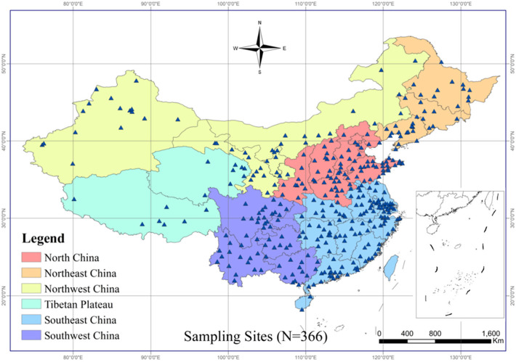

Table position should be centered, Arial,12.

Figure 1: Geographic location of 366 urban areas included in this study

In the discussion, interpret and explain your findings. Highlight the significance of the study and its importance. It is advisable to present a combination of your findings, supported by studies, insights, and arguments from previous scholars cited in the literature review section. If your findings differ from your hypothesis, explain the reasons for the discrepancy.

**4.0 Conclusion(s) and Recommendation(s)**

All text must be in [Arial, 12-point font, justified alignment, and single spacing]. Present the main conclusions drawn from your study. Base the conclusion on these findings. This section is an important part of your research as it offers readers insights into the practical implications and provides a roadmap for future research on the topic.

### Acknowledgements

### This section is at the discretion of the author. Authors who wish to acknowledge any assistance or encouragement from colleagues, special work by technical staff, or financial support from organizations should do so in the Acknowledgements section, which is not included in the numbered sections following the final section of the paper.

**References**

The references should be placed at the end of the paper in alphabetical order by the author's last name. The reference format should follow the **American Psychological Association (APA)** style (6th edition – for more details, visit http://www.apastyle.org/). All text should be in [Arial, 12-point font].

**(Book style -** Author, year. *Title (in italics).* Publisher, location of publisher.**)**

Cichocki, A. and Unbehaven, R., (1993). *Neural Networks for Optimization and Signal Processing*, 1st ed. Chichester, U.K.: Wiley.

Chen, W. K. (1993). *Linear Networks and Systems*, Belmont, CA: Wadsworth, pp. 123-135.

**(Journal -** Author, year. Paper title. *Journal name (in italics)*, volume and issue numbers, inclusive pages.**)**

Chen, S., Mulgrew, B. and Granta, P. M. (1993). “A clustering technique for digital communications channel equalization using radial basis function networks,” *IEEE Trans. on Neural Networks*, vol. 4, pp. 570-578.

Hill, R. M. (1997). The single-vendor single-buyer integrated production–inventory model with a generalized policy, *European Journal of Operational Research*, vol. 97, pp. 493-499.

**(Online Sources style)**

Vidmar, R. J. (August 1992). On the use of atmospheric plasmas as electromagnetic reflectors. IEEE Trans. Plasma Sci. [Online]. 21(3). pp. 876-880. Available: <http://www.halcyon.com/pub/journals/21ps03-vidmar>

**(Conference paper or contributed volume -** Author, year, paper title. *Proceedings title (in italics)*. City, country, inclusive pages.**)**

Beck, K. and Ralph, J. (1994). Patterns Generates Architectures. *Proceedings of European Conference of Object-Oriented Programming.* Bologna, Italy, pp. 139-149. pa0000166